WellPlanTM Report

Нефть Шельф
Well Name: PHS-1
Wellbore:
Design:
Case: PHS-1

Date: April 7, 2026 at 6:30 PM

Created By: edm

General Information
  - General Case Information
Company | Нефть Шельф
Project | Нагнетательная скважина | Site | МЛСП
Well | PHS-1 | Wellbore
Design |  | Case | PHS-1
Hole MD | 2920,00 m | Hole TVD | 2188,11 m
Air Gap | 35,00 m | Water Depth | 50,00 m
Reference Point | Datum #1 @ m | Well Type | Platform
  - Active Fluid

Fluid Data
Fluid | Mud #1 | Type | Mud
Mud Base Type | Brine | Base Fluid | Brine
Rheology Model | Newtonian | Foamed

Compressibility Data
Oil (Vol)/Water (Vol) | 80,00 %/20,00 % | Reference Temperature | 21,111
Salt Content (wt) | 10,00 | Average Solid Gravity | 2,000

Rheology Data
Temperature  (°C) | Pressure  (kPa) | Base Density  (kg/m³) | Ref Fluid Properties | PV (Mulnf)  (mPa*s) | Fann Data
 |  |  |  |  | Speed  (rpm) | Dial  (°)
21,111 | 101,35 | 812 | Yes | 24
  - Hole Section
Section  Type | Section Depth  (m) | Section Length  (m) | Shoe Depth  (m) | ID  (mm) | Drift  (mm) | Eff. Hole Diameter  (mm) | Coefficient  of  Friction | Linear Capacity  (L/m) | Volume  Excess  (%)
Casing | 2920 | 2920 | 2920 | 220,5 | 219,08 | 311,15 | 0,23 | 38,19
  - String Details
Type | Length  (m) | Depth  (m) | Body |  | Stabilizer / Tool Joint |  |  |  | Weight | Material | Grade | Class
 |  |  | OD  (mm) | ID  (mm) | Avg Joint Length  (m) | Length  (m) | OD  (mm) | ID  (mm)
Tubing | 2918 | 2918 | 139,7 | 124,26 |  |  |  |  | 25,3 | CS_API 5CT | L-80
Packer | 2 | 2920 | 214 | 100,5 | 2 |  |  |  | 50 | CS_API 5CT | 4145H MOD

Grade in Use
Grade | Minimum Yield Stress (kPa)
4145H MOD | 758 423
L-80 | 551 581
  - Wellpath - Calculation Method: Minimum Curvature
MD  (m) | INC  (°) | AZ  (°) | TVD  (m) | DLS  (°/30m) | AbsTort  (°/30m) | RelTort  (°/30m) | VSect  (m) | NS  (m) | EW  (m) | Build  (°/30m) | Walk  (°/30m)
0,00 | 0,00 | 0,00 | 0,00 | 0,000 | 0,000 | 0,000 | 0,00 | 0,00 | 0,00 | 0,000 | 0,000
10,00 | 0,20 | 292,48 | 10,00 | 0,600 | 0,600 | 0,000 | 0,01 | 0,01 | -0,02 | 0,600 | 0,000
20,00 | 0,20 | 268,18 | 20,00 | 0,253 | 0,426 | 0,000 | 0,01 | 0,01 | -0,05 | 0,000 | -72,900
30,00 | 0,19 | 238,31 | 30,00 | 0,303 | 0,385 | 0,000 | 0,00 | 0,00 | -0,08 | -0,030 | -89,610
40,00 | 0,17 | 205,72 | 40,00 | 0,308 | 0,366 | 0,000 | -0,02 | -0,02 | -0,10 | -0,060 | -97,770
50,00 | 0,17 | 176,46 | 50,00 | 0,258 | 0,344 | 0,000 | -0,05 | -0,05 | -0,11 | 0,000 | -87,780
60,00 | 0,21 | 124,84 | 60,00 | 0,508 | 0,372 | 0,000 | -0,07 | -0,07 | -0,09 | 0,120 | -154,860
61,78 | 0,22 | 119,98 | 61,78 | 0,350 | 0,371 | 0,000 | -0,08 | -0,08 | -0,09 | 0,169 | -81,910
70,00 | 0,28 | 102,92 | 70,00 | 0,347 | 0,368 | 0,000 | -0,09 | -0,09 | -0,05 | 0,219 | -62,263
80,00 | 0,34 | 77,73 | 80,00 | 0,442 | 0,377 | 0,000 | -0,09 | -0,09 | 0,00 | 0,180 | -75,570
85,00 | 0,38 | 71,22 | 85,00 | 0,343 | 0,375 | 0,000 | -0,08 | -0,08 | 0,03 | 0,240 | -39,060
90,00 | 0,38 | 37,93 | 90,00 | 1,306 | 0,427 | 0,000 | -0,06 | -0,06 | 0,06 | 0,000 | -199,740
100,00 | 0,38 | 39,43 | 100,00 | 0,030 | 0,387 | 0,000 | -0,01 | -0,01 | 0,10 | 0,000 | 4,500
108,00 | 0,54 | 13,28 | 108,00 | 0,975 | 0,431 | 0,000 | 0,05 | 0,05 | 0,12 | 0,600 | -98,063
110,00 | 0,60 | 15,59 | 110,00 | 0,964 | 0,441 | 0,000 | 0,07 | 0,07 | 0,13 | 0,900 | 34,650
117,00 | 0,89 | 359,76 | 117,00 | 1,513 | 0,505 | 0,000 | 0,16 | 0,16 | 0,14 | 1,243 | -67,843
127,00 | 1,29 | 345,84 | 127,00 | 1,431 | 0,578 | 0,000 | 0,34 | 0,34 | 0,11 | 1,200 | -41,760
136,00 | 2,05 | 343,05 | 135,99 | 2,547 | 0,708 | 0,000 | 0,60 | 0,60 | 0,04 | 2,533 | -9,300
150,00 | 3,63 | 343,68 | 149,97 | 3,386 | 0,958 | 0,000 | 1,26 | 1,26 | -0,16 | 3,386 | 1,350
160,00 | 4,18 | 345,60 | 159,95 | 1,696 | 1,004 | 0,000 | 1,92 | 1,92 | -0,34 | 1,650 | 5,760
170,00 | 4,41 | 348,47 | 169,92 | 0,944 | 1,001 | 0,000 | 2,65 | 2,65 | -0,51 | 0,690 | 8,610
180,00 | 5,24 | 350,09 | 179,89 | 2,523 | 1,085 | 0,000 | 3,47 | 3,47 | -0,66 | 2,490 | 4,860
190,00 | 6,15 | 349,74 | 189,84 | 2,732 | 1,172 | 0,000 | 4,45 | 4,45 | -0,84 | 2,730 | -1,050
200,00 | 6,86 | 346,61 | 199,77 | 2,380 | 1,232 | 0,000 | 5,56 | 5,56 | -1,07 | 2,130 | -9,390
210,00 | 7,37 | 347,15 | 209,70 | 1,543 | 1,247 | 0,000 | 6,77 | 6,77 | -1,35 | 1,530 | 1,620
220,00 | 7,76 | 346,64 | 219,61 | 1,187 | 1,244 | 0,000 | 8,05 | 8,05 | -1,65 | 1,170 | -1,530
230,00 | 8,23 | 346,59 | 229,51 | 1,410 | 1,251 | 0,000 | 9,40 | 9,40 | -1,97 | 1,410 | -0,150
240,00 | 8,50 | 345,28 | 239,41 | 0,991 | 1,241 | 0,000 | 10,81 | 10,81 | -2,32 | 0,810 | -3,930
250,00 | 8,30 | 343,68 | 249,30 | 0,923 | 1,228 | 0,000 | 12,22 | 12,22 | -2,72 | -0,600 | -4,800
260,00 | 8,17 | 338,80 | 259,20 | 2,132 | 1,263 | 0,000 | 13,58 | 13,58 | -3,18 | -0,390 | -14,640
270,00 | 8,67 | 339,16 | 269,09 | 1,508 | 1,272 | 0,000 | 14,94 | 14,94 | -3,70 | 1,500 | 1,080
282,11 | 9,48 | 342,78 | 281,05 | 2,454 | 1,323 | 0,000 | 16,75 | 16,75 | -4,32 | 2,007 | 8,968
309,20 | 10,25 | 347,82 | 307,74 | 1,280 | 1,319 | 0,000 | 21,23 | 21,23 | -5,49 | 0,853 | 5,581
337,58 | 11,60 | 345,22 | 335,60 | 1,519 | 1,336 | 0,000 | 26,46 | 26,46 | -6,75 | 1,427 | -2,748
366,14 | 13,07 | 346,37 | 363,50 | 1,565 | 1,354 | 0,000 | 32,38 | 32,38 | -8,24 | 1,544 | 1,208
394,93 | 16,00 | 345,57 | 391,37 | 3,060 | 1,478 | 0,000 | 39,38 | 39,38 | -10,00 | 3,053 | -0,834
422,85 | 17,92 | 343,66 | 418,07 | 2,148 | 1,522 | 0,000 | 47,23 | 47,23 | -12,17 | 2,063 | -2,052
451,02 | 22,27 | 344,09 | 444,52 | 4,635 | 1,717 | 0,000 | 56,53 | 56,53 | -14,85 | 4,633 | 0,458
479,18 | 21,88 | 346,20 | 470,62 | 0,941 | 1,671 | 0,000 | 66,76 | 66,76 | -17,57 | -0,415 | 2,248
507,31 | 19,14 | 346,35 | 496,96 | 2,923 | 1,741 | 0,000 | 76,33 | 76,33 | -19,90 | -2,922 | 0,160
535,33 | 18,81 | 344,96 | 523,46 | 0,599 | 1,681 | 0,000 | 85,16 | 85,16 | -22,16 | -0,353 | -1,488
584,02 | 24,42 | 343,14 | 568,71 | 3,481 | 1,831 | 0,000 | 102,38 | 102,38 | -27,12 | 3,457 | -1,121
612,48 | 26,36 | 340,11 | 594,42 | 2,461 | 1,860 | 0,000 | 113,96 | 113,96 | -30,98 | 2,045 | -3,194
640,52 | 27,57 | 339,43 | 619,41 | 1,336 | 1,837 | 0,000 | 125,89 | 125,89 | -35,38 | 1,295 | -0,728
668,65 | 28,35 | 333,78 | 644,26 | 2,944 | 1,884 | 0,000 | 137,98 | 137,98 | -40,61 | 0,832 | -6,026
696,83 | 28,75 | 332,57 | 669,01 | 0,749 | 1,838 | 0,000 | 149,99 | 149,99 | -46,69 | 0,426 | -1,288
724,84 | 29,25 | 329,23 | 693,51 | 1,815 | 1,837 | 0,000 | 161,85 | 161,85 | -53,30 | 0,536 | -3,577
753,33 | 31,03 | 327,06 | 718,15 | 2,197 | 1,851 | 0,000 | 174,00 | 174,00 | -60,85 | 1,874 | -2,285
781,47 | 33,52 | 326,79 | 741,94 | 2,659 | 1,880 | 0,000 | 186,59 | 186,59 | -69,05 | 2,655 | -0,288
809,67 | 36,17 | 325,70 | 765,08 | 2,896 | 1,915 | 0,000 | 199,98 | 199,98 | -78,01 | 2,819 | -1,160
837,91 | 38,22 | 325,14 | 787,58 | 2,207 | 1,925 | 0,000 | 214,03 | 214,03 | -87,70 | 2,178 | -0,595
866,21 | 40,45 | 325,23 | 809,47 | 2,365 | 1,939 | 0,000 | 228,76 | 228,76 | -97,94 | 2,364 | 0,095
894,31 | 41,59 | 323,16 | 830,67 | 1,893 | 1,938 | 0,000 | 243,71 | 243,71 | -108,73 | 1,217 | -2,210
922,89 | 42,95 | 321,94 | 851,82 | 1,667 | 1,929 | 0,000 | 258,97 | 258,97 | -120,42 | 1,428 | -1,281
950,69 | 43,92 | 319,93 | 872,00 | 1,822 | 1,926 | 0,000 | 273,81 | 273,81 | -132,47 | 1,047 | -2,169
979,54 | 45,16 | 317,06 | 892,57 | 2,458 | 1,942 | 0,000 | 288,95 | 288,95 | -145,88 | 1,289 | -2,984
1007,25 | 46,88 | 317,00 | 911,81 | 1,863 | 1,940 | 0,000 | 303,54 | 303,54 | -159,47 | 1,862 | -0,065
1035,27 | 47,46 | 318,84 | 930,86 | 1,573 | 1,930 | 0,000 | 318,80 | 318,80 | -173,24 | 0,621 | 1,970
1063,44 | 47,57 | 318,91 | 949,88 | 0,129 | 1,882 | 0,000 | 334,44 | 334,44 | -186,90 | 0,117 | 0,075
1092,25 | 46,99 | 318,52 | 969,43 | 0,674 | 1,850 | 0,000 | 350,35 | 350,35 | -200,87 | -0,604 | -0,406
1120,04 | 46,93 | 318,49 | 988,40 | 0,069 | 1,806 | 0,000 | 365,56 | 365,56 | -214,32 | -0,065 | -0,032
1148,25 | 46,81 | 317,88 | 1007,68 | 0,490 | 1,774 | 0,000 | 380,91 | 380,91 | -228,05 | -0,128 | -0,649
1176,33 | 47,60 | 318,48 | 1026,76 | 0,966 | 1,754 | 0,000 | 396,26 | 396,26 | -241,79 | 0,844 | 0,641
1204,53 | 48,20 | 317,78 | 1045,67 | 0,844 | 1,733 | 0,000 | 411,84 | 411,84 | -255,75 | 0,638 | -0,745
1232,48 | 48,12 | 317,03 | 1064,31 | 0,606 | 1,708 | 0,000 | 427,17 | 427,17 | -269,85 | -0,086 | -0,805
1260,31 | 48,10 | 316,26 | 1082,89 | 0,618 | 1,684 | 0,000 | 442,24 | 442,24 | -284,07 | -0,022 | -0,830
1288,61 | 47,87 | 316,90 | 1101,83 | 0,560 | 1,659 | 0,000 | 457,51 | 457,51 | -298,52 | -0,244 | 0,678
1316,72 | 47,72 | 317,18 | 1120,72 | 0,273 | 1,629 | 0,000 | 472,75 | 472,75 | -312,71 | -0,160 | 0,299
1344,74 | 48,10 | 317,05 | 1139,50 | 0,420 | 1,604 | 0,000 | 487,98 | 487,98 | -326,86 | 0,407 | -0,139
1373,17 | 48,26 | 316,44 | 1158,46 | 0,509 | 1,581 | 0,000 | 503,41 | 503,41 | -341,38 | 0,169 | -0,644
1401,25 | 48,31 | 316,00 | 1177,14 | 0,355 | 1,557 | 0,000 | 518,55 | 518,55 | -355,88 | 0,053 | -0,470
1429,39 | 48,25 | 316,57 | 1195,87 | 0,458 | 1,535 | 0,000 | 533,73 | 533,73 | -370,40 | -0,064 | 0,608
1457,34 | 47,44 | 316,81 | 1214,63 | 0,890 | 1,523 | 0,000 | 548,80 | 548,80 | -384,61 | -0,869 | 0,258
1485,35 | 47,79 | 317,22 | 1233,51 | 0,496 | 1,503 | 0,000 | 563,94 | 563,94 | -398,72 | 0,375 | 0,439
1513,51 | 47,73 | 316,73 | 1252,44 | 0,392 | 1,483 | 0,000 | 579,18 | 579,18 | -412,94 | -0,064 | -0,522
1541,46 | 47,65 | 316,75 | 1271,25 | 0,087 | 1,457 | 0,000 | 594,23 | 594,23 | -427,11 | -0,086 | 0,021
1569,61 | 47,39 | 318,64 | 1290,27 | 1,511 | 1,458 | 0,000 | 609,58 | 609,58 | -441,08 | -0,277 | 2,014
1597,76 | 47,70 | 318,41 | 1309,27 | 0,377 | 1,439 | 0,000 | 625,14 | 625,14 | -454,83 | 0,330 | -0,245
1625,76 | 47,92 | 318,91 | 1328,07 | 0,462 | 1,423 | 0,000 | 640,72 | 640,72 | -468,54 | 0,236 | 0,536
1654,05 | 48,29 | 319,45 | 1346,96 | 0,579 | 1,408 | 0,000 | 656,66 | 656,66 | -482,30 | 0,392 | 0,573
1682,31 | 48,05 | 318,45 | 1365,81 | 0,831 | 1,398 | 0,000 | 672,54 | 672,54 | -496,13 | -0,255 | -1,062
1710,46 | 48,13 | 318,74 | 1384,61 | 0,245 | 1,379 | 0,000 | 688,25 | 688,25 | -509,99 | 0,085 | 0,309
1738,43 | 47,78 | 317,88 | 1403,35 | 0,781 | 1,370 | 0,000 | 703,76 | 703,76 | -523,80 | -0,375 | -0,922
1766,35 | 48,05 | 318,48 | 1422,06 | 0,560 | 1,357 | 0,000 | 719,20 | 719,20 | -537,62 | 0,290 | 0,645
1795,24 | 48,09 | 318,28 | 1441,36 | 0,160 | 1,338 | 0,000 | 735,27 | 735,27 | -551,89 | 0,042 | -0,208
1822,92 | 47,87 | 319,15 | 1459,89 | 0,740 | 1,329 | 0,000 | 750,72 | 750,72 | -565,46 | -0,238 | 0,943
1851,23 | 48,19 | 319,08 | 1478,82 | 0,344 | 1,314 | 0,000 | 766,64 | 766,64 | -579,24 | 0,339 | -0,074
1879,24 | 47,86 | 318,37 | 1497,56 | 0,667 | 1,304 | 0,000 | 782,29 | 782,29 | -592,97 | -0,353 | -0,760
1907,38 | 47,62 | 318,57 | 1516,48 | 0,301 | 1,289 | 0,000 | 797,88 | 797,88 | -606,78 | -0,256 | 0,213
1935,11 | 47,63 | 319,19 | 1535,17 | 0,496 | 1,278 | 0,000 | 813,31 | 813,31 | -620,25 | 0,011 | 0,671
1963,62 | 48,08 | 318,51 | 1554,30 | 0,711 | 1,270 | 0,000 | 829,23 | 829,23 | -634,16 | 0,474 | -0,716
1991,69 | 48,08 | 318,76 | 1573,05 | 0,199 | 1,254 | 0,000 | 844,90 | 844,90 | -647,97 | 0,000 | 0,267
2019,97 | 48,24 | 318,90 | 1591,92 | 0,203 | 1,240 | 0,000 | 860,76 | 860,76 | -661,84 | 0,170 | 0,149
2048,26 | 47,71 | 318,45 | 1610,86 | 0,664 | 1,232 | 0,000 | 876,54 | 876,54 | -675,71 | -0,562 | -0,477
2076,19 | 47,43 | 320,62 | 1629,70 | 1,746 | 1,239 | 0,000 | 892,22 | 892,22 | -689,09 | -0,301 | 2,331
2104,46 | 47,89 | 322,01 | 1648,74 | 1,195 | 1,238 | 0,000 | 908,54 | 908,54 | -702,15 | 0,488 | 1,475
2132,61 | 48,16 | 321,91 | 1667,57 | 0,298 | 1,226 | 0,000 | 925,02 | 925,02 | -715,05 | 0,288 | -0,107
2160,81 | 48,09 | 321,54 | 1686,40 | 0,302 | 1,214 | 0,000 | 941,50 | 941,50 | -728,05 | -0,074 | -0,394
2189,05 | 47,98 | 323,71 | 1705,28 | 1,718 | 1,220 | 0,000 | 958,19 | 958,19 | -740,80 | -0,117 | 2,305
2217,27 | 47,71 | 324,42 | 1724,22 | 0,629 | 1,213 | 0,000 | 975,12 | 975,12 | -753,08 | -0,287 | 0,755
2246,40 | 48,24 | 323,52 | 1743,72 | 0,879 | 1,208 | 0,000 | 992,62 | 992,62 | -765,80 | 0,546 | -0,927
2273,41 | 48,32 | 323,31 | 1761,70 | 0,195 | 1,196 | 0,000 | 1008,81 | 1008,81 | -777,82 | 0,089 | -0,233
2301,53 | 47,87 | 324,59 | 1780,48 | 1,124 | 1,195 | 0,000 | 1025,73 | 1025,73 | -790,14 | -0,480 | 1,366
2329,78 | 47,37 | 324,90 | 1799,52 | 0,584 | 1,188 | 0,000 | 1042,77 | 1042,77 | -802,18 | -0,531 | 0,329
2358,11 | 47,99 | 326,22 | 1818,59 | 1,224 | 1,188 | 0,000 | 1060,05 | 1060,05 | -814,03 | 0,657 | 1,398
2384,57 | 48,49 | 327,00 | 1836,22 | 0,870 | 1,185 | 0,000 | 1076,53 | 1076,53 | -824,89 | 0,567 | 0,884
2413,10 | 48,83 | 327,41 | 1855,06 | 0,482 | 1,177 | 0,000 | 1094,53 | 1094,53 | -836,49 | 0,358 | 0,431
2441,29 | 48,68 | 328,46 | 1873,65 | 0,855 | 1,173 | 0,000 | 1112,50 | 1112,50 | -847,74 | -0,160 | 1,117
2469,52 | 48,60 | 327,90 | 1892,30 | 0,455 | 1,165 | 0,000 | 1130,50 | 1130,50 | -858,91 | -0,085 | -0,595
2497,89 | 48,17 | 328,15 | 1911,14 | 0,496 | 1,157 | 0,000 | 1148,49 | 1148,49 | -870,15 | -0,455 | 0,264
2526,18 | 48,14 | 328,29 | 1930,01 | 0,115 | 1,145 | 0,000 | 1166,41 | 1166,41 | -881,25 | -0,032 | 0,148
2554,31 | 48,22 | 328,56 | 1948,77 | 0,231 | 1,135 | 0,000 | 1184,27 | 1184,27 | -892,22 | 0,085 | 0,288
2582,42 | 48,20 | 329,36 | 1967,50 | 0,637 | 1,130 | 0,000 | 1202,22 | 1202,22 | -903,03 | -0,021 | 0,854
2610,33 | 47,90 | 329,31 | 1986,16 | 0,325 | 1,121 | 0,000 | 1220,08 | 1220,08 | -913,62 | -0,322 | -0,054
2638,48 | 47,88 | 328,79 | 2005,04 | 0,412 | 1,114 | 0,000 | 1237,99 | 1237,99 | -924,36 | -0,021 | -0,554
2666,70 | 47,79 | 326,84 | 2023,98 | 1,539 | 1,118 | 0,000 | 1255,69 | 1255,69 | -935,50 | -0,096 | -2,073
2694,91 | 47,76 | 326,79 | 2042,94 | 0,051 | 1,107 | 0,000 | 1273,17 | 1273,17 | -946,93 | -0,032 | -0,053
2723,01 | 47,70 | 326,95 | 2061,84 | 0,142 | 1,097 | 0,000 | 1290,59 | 1290,59 | -958,29 | -0,064 | 0,171
2751,23 | 47,74 | 326,83 | 2080,83 | 0,104 | 1,087 | 0,000 | 1308,07 | 1308,07 | -969,70 | 0,043 | -0,128
2778,95 | 47,59 | 325,41 | 2099,49 | 1,148 | 1,088 | 0,000 | 1325,09 | 1325,09 | -981,12 | -0,162 | -1,537
2807,51 | 47,57 | 326,15 | 2118,76 | 0,574 | 1,082 | 0,000 | 1342,52 | 1342,52 | -992,98 | -0,021 | 0,777
2835,92 | 50,08 | 326,70 | 2137,46 | 2,686 | 1,098 | 0,000 | 1360,34 | 1360,34 | -1004,80 | 2,650 | 0,581
2864,09 | 52,34 | 328,10 | 2155,11 | 2,673 | 1,114 | 0,000 | 1378,83 | 1378,83 | -1016,63 | 2,407 | 1,491
2892,61 | 54,17 | 329,05 | 2172,17 | 2,085 | 1,123 | 0,000 | 1398,33 | 1398,33 | -1028,54 | 1,925 | 0,999
2920,80 | 54,70 | 329,08 | 2188,57 | 0,565 | 1,118 | 0,000 | 1418,00 | 1418,00 | -1040,33 | 0,564 | 0,032
  - Pore Pressure
True Vertical Depth (TVD)  (m) | Pore Pressure  (kPa) | Equivalent Mud Weight (EMW)  (kg/m³)
85,00 | 859,00 | 1031
  - Fracture Gradient
True Vertical Depth (TVD)  (m) | Fracture Pressure  (kPa) | Equivalent Mud Weight (EMW)  (kg/m³)
85,00 | 0,00 | 0
  - Geothermal Gradient Data
Ambient Temperature | 10,000 °C | Mudline Temperature | 1,000 °C
Temperature @ Depth | 70,000 °C @ 2188,11 m | Gradient | 3,28 °C/100m

Schematics
Well: | IH-9 | Wellbore: |  | Case: | IH-9 | String Name: | Assembly
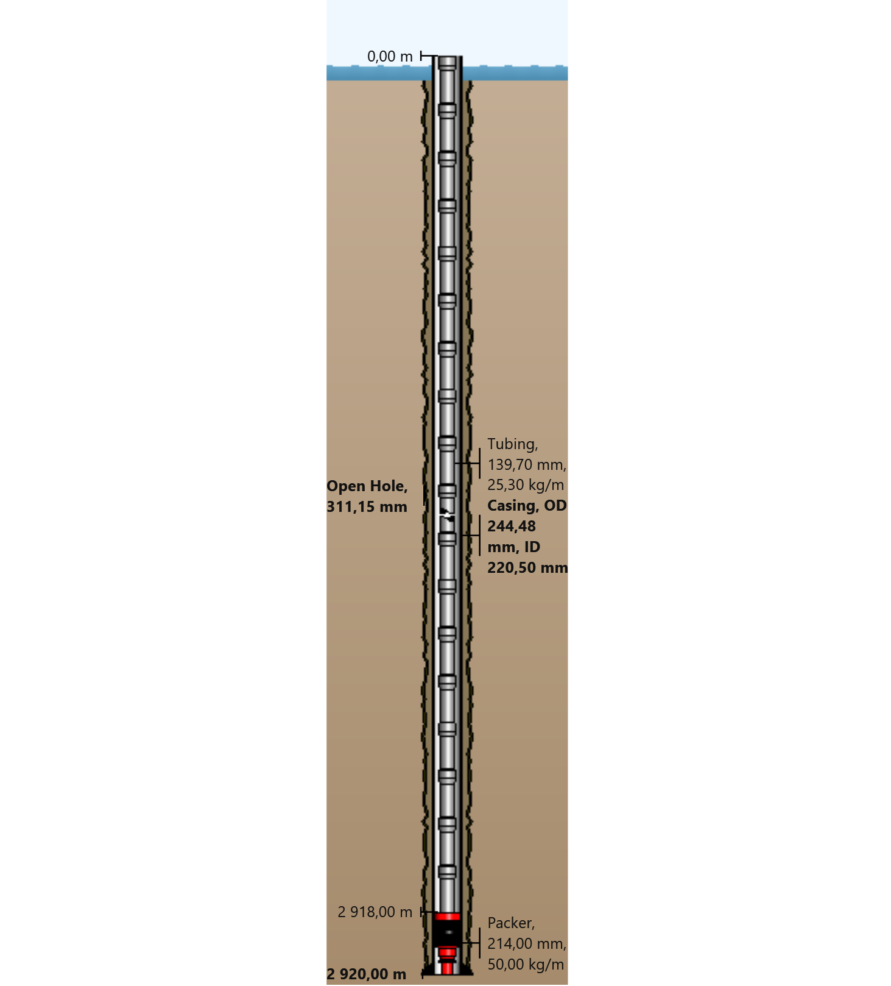

General Outputs Plots
  - Vertical Section
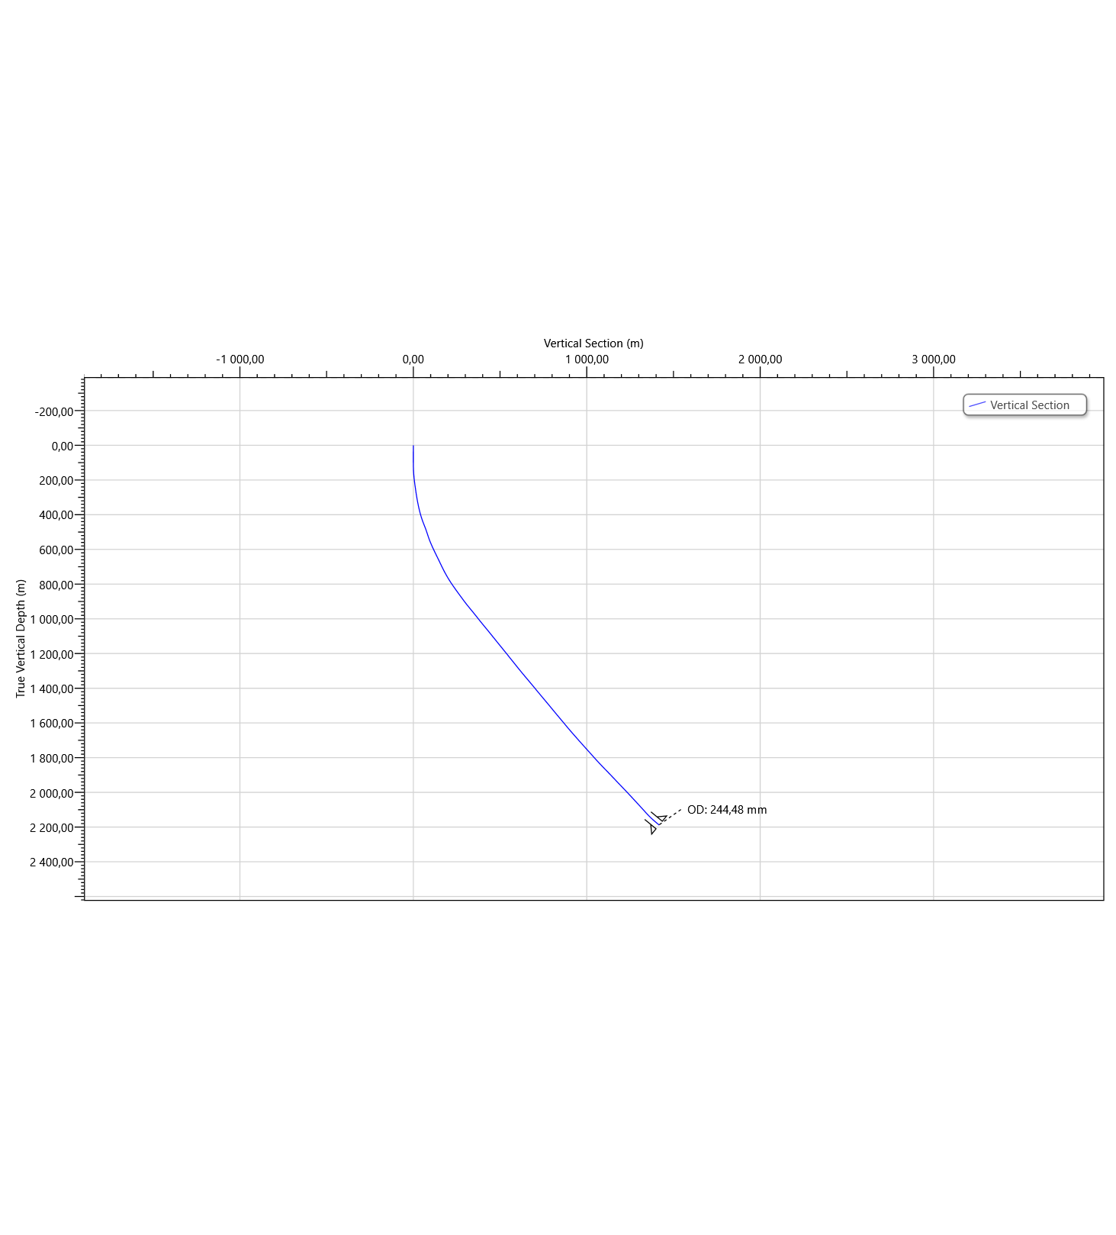
  - Plan View
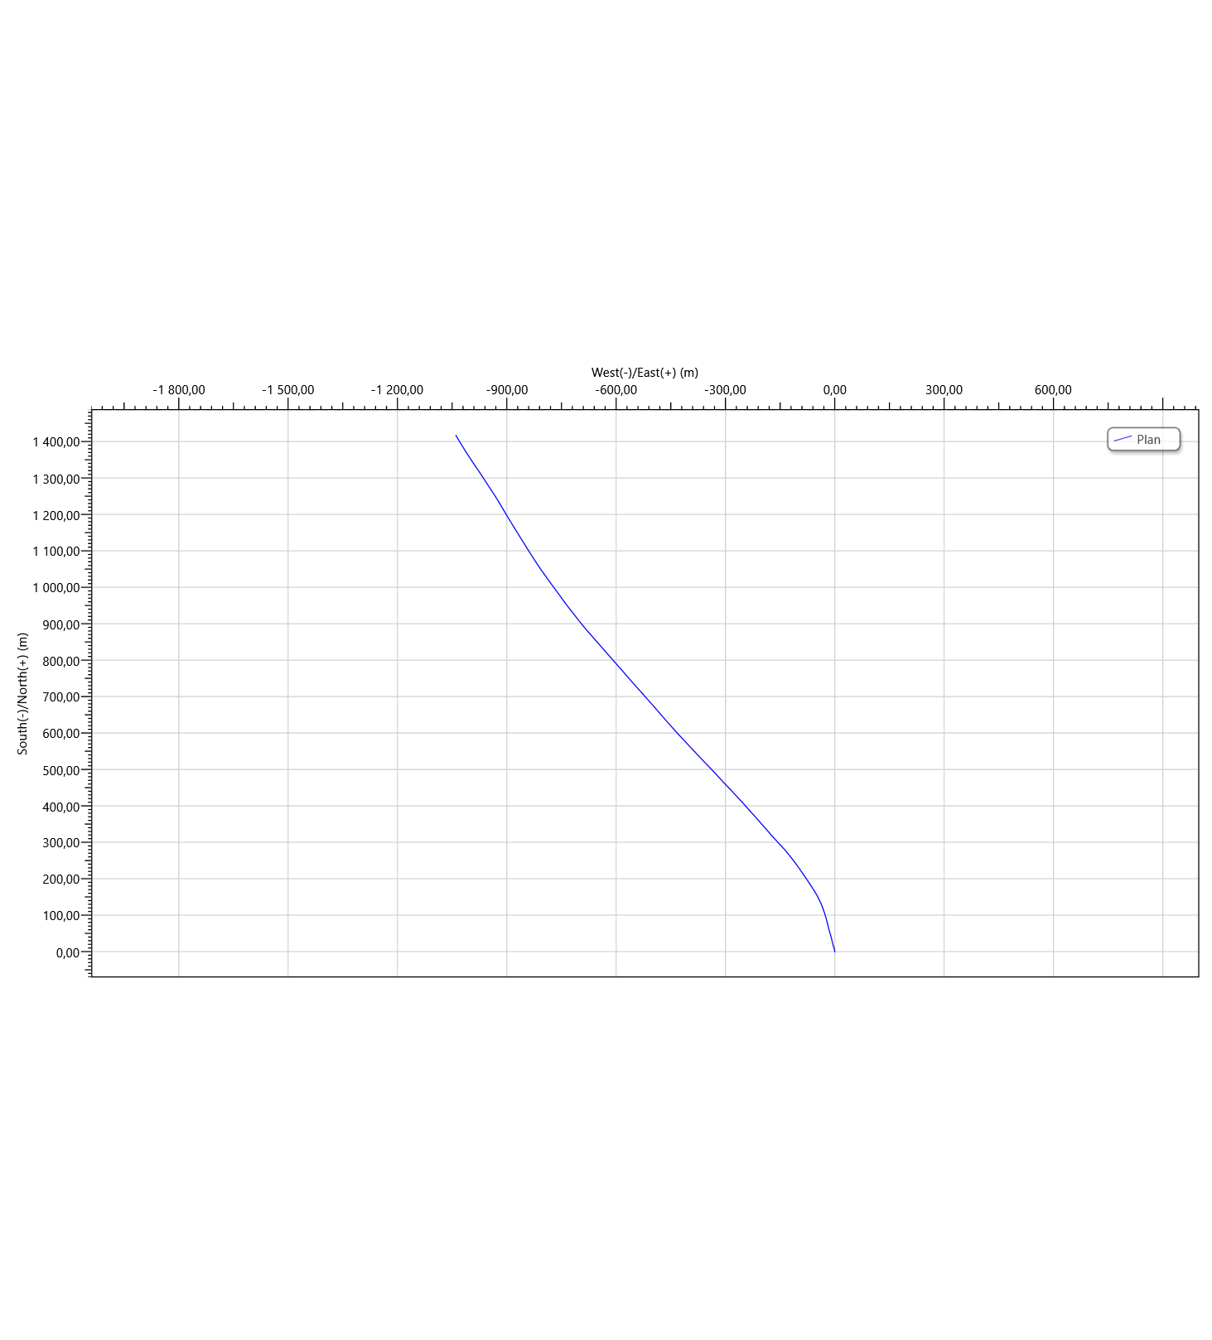

Torque & Drag Setup Data
  - Settings
Measured Depth of Bit | 2920,00 m | Bending Stress Magnification | No
Block Weight | 0,00 tonne | Stiff String Analysis | No
Enable Sheave Friction Correction | No | Viscous Torque and Drag | No
Pump Rate | 0,0000 m³/min | Contact Force Normalization Length | 9,45 m
Mechanical Efficiency (Single Sheave) | 97,00 | Lines Strung | 12
 |  | Side Force | N
Offset from Wellhead | m | Angle at Wellhead | °
  - Run Parameters
Start MD | 0,00 m | End MD | 2920,00 m
Step Size | 30,00 m
  - Normal Analysis Operational Parameters
Drilling | WOP/Overpull  (tonne) | Torque at Bit  (N-m)
Rotating On Bottom | NA | NA
Slide Drilling | NA | NA
Backreaming | NA | NA
Rotating Off Bottom
Tripping | Speed  (m/min) | RPM  (rpm)
Tripping In | 10,00 | 0
Tripping Out | 10,00 | 0
  - Friction Factors
Section Type | Coefficient of Friction
Casing | 0,23

  - String Fill Up
Use String Fill Up (Tripping In only) | No | Period | 0,00 m

Torque and Drag Results
  - Mechanical Limitations
Overpull Margin during a Tripping Out operation | 104,91 tonne | using | 100,00% of yield
Minimum Weight on Bit to Sinusoidal Buckle during a rotating on bottom operation | 17,59 tonne | at | 2772,10 m
Minimum Weight on Bit to Helical Buckle during a rotating on bottom operation | 24,00 tonne | at | 2772,10 m
Pick-Up Drag | 19,11 tonne
Slack-Off Drag | 13,28 tonne
Block Rating (Hoisting System) | tonne
Torque Rating (Rotating Equipment) | N-m
  - Load Summary
Load Condition | Stress Failure |  |  | Buckling Limits |  |  | Torque Failure | Torque at the Rotary Table  (N-m) | Total Windup with Bit Torque  (revs) | Total Windup without Bit Torque  (revs) | Measured Weight  (tonne) | Total Stretch  (m) | Axial Stress = 0 |  | Neutral Point Distance from surface  (m) | Neutral Point Distance from Bit  (m)
 | Fatigue | 90% Yield | 100% Yield | Sinusoidal | Helical | Lockup |  |  |  |  |  |  | Distance from Surface  (m) | Distance from Bit  (m)
Tripping In |  |  |  |  |  |  |  | 0,0 | 0,0 | 0,0 | 36,39 | 1,66 | 2473,18 | 446,82 | 2920,00 | 0,00
Tripping Out |  |  |  |  |  |  |  | 0,0 | 0,0 | 0,0 | 68,79 | 2,22 | 2639,37 | 280,63 | 2920,00 | 0,00

Torque and Drag Plots
  - Effective Tension
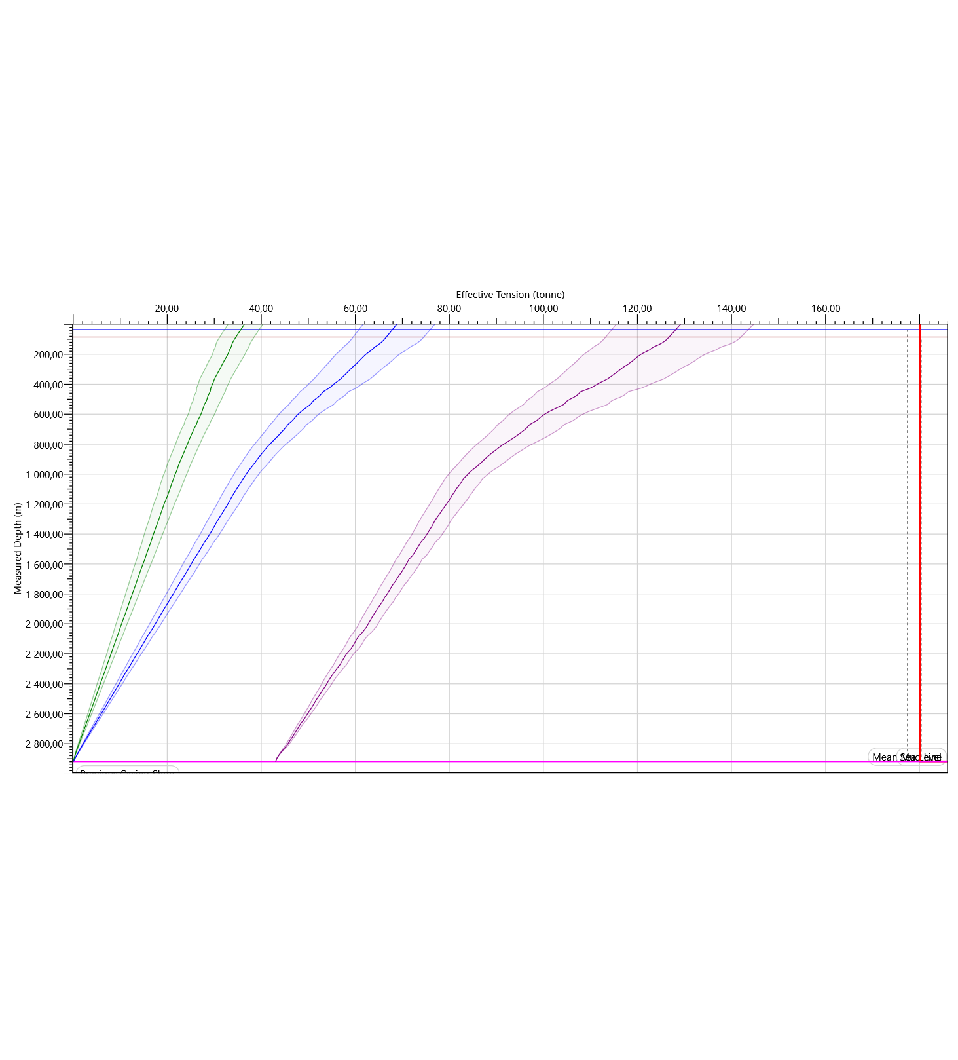
  - Hook Load
